**Literature survey**

1. P. Kavipriya1, G. Jegan and Edara Venkat (2021), “Design of IOT Based Multifunctional Camouflage Military Robot".

* The main principle of the army robot is based on camouflage techniques. It basically consists of a vehicle mounted with one camera, which captures the images and detects color accordingly as a part of the camouflaging feature.
* This paper has proposed the system using the Arduino Mega, metal detector, PIR sensor, IR sensor, RFID, color sensor, gas sensor which helps the robot to do multi-functionalities and rescue operations.
* This System consist PIR sensor, IR sensor for detecting any intruders, movement of animals, humans and Metal detector to detect the presence of metal arms and weapons nearby, color sensor to camouflage the robot, gas sensors to detect the toxic gases that are present in surroundings.
* It is operated using a WI-FI module which is based on the IEEE standard 802.11. It is the interface between the user and the system. The motor driver circuit drives the Robot as per the commands given by the user using Wi-Fi module. It can only receive the information from the sensors.
* This paper concludes that camouflage robot, which detects the gases, intruders, obstacles, metal weapons that are present in the surroundings and give the commands and send the information to the nearest camp.

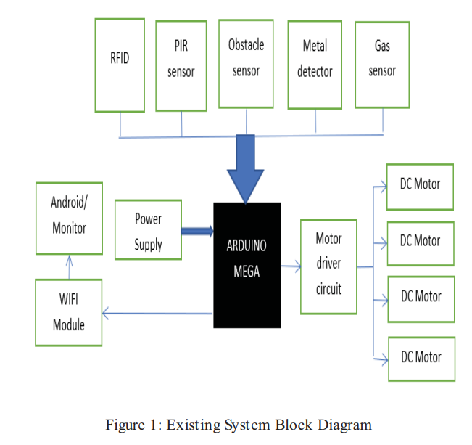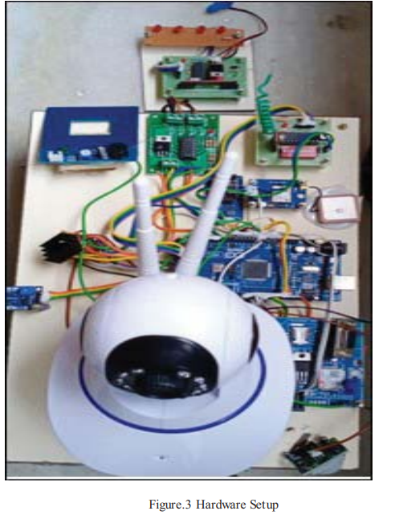

2. Vidya Kodgirwar, Shreeya Deshpande, Reema Damle (2020) “7th Sense: A Multipurpose Robot for Military”

* It is a multipurpose robot which communicates through RF Module consisting of ATmega16 microcontroller, smoke and fire sensor, Metal detector, PIR sensor, buzzer, LCD display, temperature sensor and web camera.
* PIR sensor senses the motion of human near the robot which has a range from 0-2m, metal sensor is provided for bomb detection and detects upto 7cm, Smoke and fire sensor senses the smoke around the robot which is having a range from 65%±5%, LCD is provided to display the different sensor readings the robot detects.
* Implementation of RF technology for transmission of information/data as well as reception is done. Output is in analog form from RF module. The RF module detects upto 30m.
* The system has two modes in which the robot get controlled. The first mode being automatic while the other mode being manual.
* In the automatic mode the robot will continuously detect objects. Decisions are taken by the robot according to the sensor reading. The robot continuously monitors and if it senses something, it will indicate it through buzzer.
* The manual mode is having full control over robot. Decisions are taken by the user by controlling it.

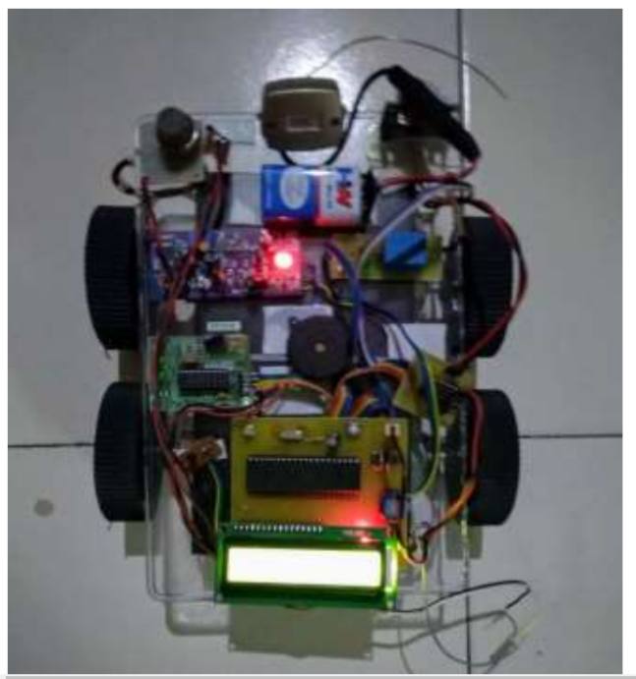Figure: Design of proposed system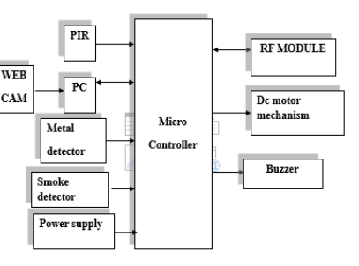 Figure: Multipurpose Robot

3. Satyam Choudry and T. Akilan (2020) “Surveillance Robot in Hazardous Place Using IOT Technology”

* This paper deals with human surveillance through the technology based on IOT featuring robotics using an Arduino UNO microcontroller. The objective is to develop a spy robotic car which is suited to provide a continuous surveillance in hazardous environment.
* This system comprises of various components like PIR sensor, ultrasonic sensor, gas sensor and ESP 8266 interfaced with Arduino board.
* For connection of the robot system to the internet through BLYNK software is used. All the communication between the smartphone and the hardware is easily managed through the customized dashboard created with the help of Blynk.
* The microcontroller is organised using the Arduino IDE software. Ultrasonic sensor measures the distance by generating high frequency sound waves notice the reflected back echo of sound waves and calculate the distance by the time taken to get back.
* The MQ-135 Gas sensor is used for the overall management of air quality and it is suitable for measuring the various hazardous gases like, LPG, Nitrous oxide, Alcohol, Benzene, Smoke, carbon dioxide.
* Depending on the sensor data of the robot, L293D provides the information to the user to move the robot in the desired direction properly like left, right, forward and backwards.
* Spy robot monitor the live streaming information and transfer it to the connected Android device. Android application can control the navigation of the robot from a large distance using WIFI communication.

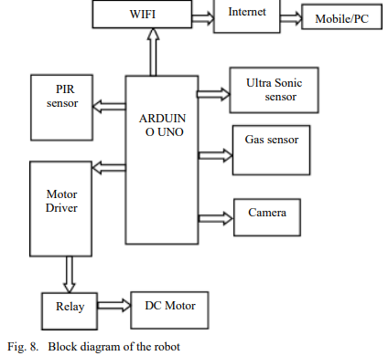 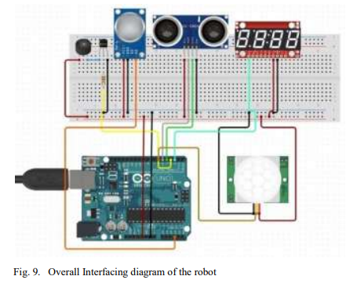

4. Divya Sharma, Usha Chauhan, (2020) "War Spying Robot with Wireless Night Vision Camera".

* To deal with the security issues such as combating of the terrorist activities by tracking their locations and reducing soldier's efforts, involvement in the mission an RF BASED spy robot is used.
* The robot mainly consists of Node MCU(ESP8266) which acts as link between the camera and the motor driver module fixed on the robot and can be used as self-contained System-On-Chip with coordinates TCP/IP convention stack that can deliver, to get our Wi-Fi arrange.
* Motor driver module act as controller to control the motion of the robot. It changes to coordinate electrical current vitality to mechanical vitality which is of 12 V and makes the motor move as per the instructions given.
* The Night Vision Camera used here are the Mi-Camera which has a cluster of infrared LEDs that helps to provide visibility even in complete darkness. As infrared light has low energetic radiation as compared to others, human eyes are able to see.
* Bylnk App is used to design four switches , i.e., left ,right, forward and reverse according to which the motion of robot could be controlled. Micro-Controller–ATmega1 is used to send commands in order to control the movement of robot left or right, front or back, up or down etc.
* The robot sends flag to the RF collector mounted on the robot through RF transmitter at the base station.

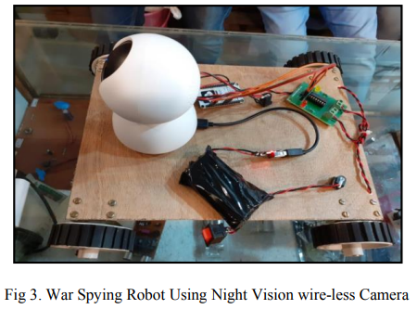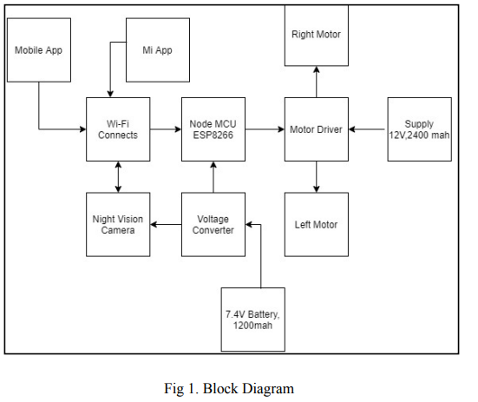

5. Bagathi Santosh Kumar, Gouri Shankar Sharma, (2018) "A Multi-Functional Robot for Remote Surveillance in Military Applications".

* The robotic vehicle is autonomous and the sensors on the robot will continuously monitor various parameters. It uses ultrasonic sensor to go through the area avoiding obstacles. Temperature and humidity sensors monitoring for surrounding environment changes. Fire and gas sensors monitoring for any bomb blasts or harmful gases.
* PIR sensor for continuous human detection whenever detected it triggers an event in the system to send the GPS coordinates via SMS as an indication.
* Arduino Mega microcontroller is used to interface GSM module and respective sensors. On-board camera on the system takes images. The images sent by camera can also be seen on the webpage.
* The robot is aided with GPS Receiver; the GPS receiver obtains the location co-ordinates. The Global Positioning System (GPS), is a radio navigation system that allows land, sea and airborne users to determine their exact location, velocity and time 24 hours a day, in all weather conditions
* The sensor data from PIR triggers the system, GPS coordinates, images taken from on-board camera are continuously sent to control station through GPRS.
* A GPS receiver on the robot along with GPRS capable GSM Modem sends this data to a server located which can be at the control station. At the central control station the data sent from the robot system is stored on to a database and is used to represent the information in a graphical view on a webpage.
* At the control station the GPS data is used to show the real time position of the robot using open source Google maps API, also the sensor data and images sent from the remote location can be seen on a webpage which can be accessible from anywhere.

